# Assessment 2: Critical analysis of the efficacy of data visualisations

*by*

*Tahmina Abedin Rimi- z5386304*

*Master of Data Science*

**The University of New South Wales (UNSW)**

**UNSW Business School**

**School of Risk & Actuarial Studies**

Estimated word count: 800

**Course (Data Visualisation and Communication –ZZBU6507)**

**Hexamester 5, 2022**

**Introduction**

To represent data and information graphically, we need data visualisation. In the era of technology, data visualisation plays a vital role in analysing things. People often don't understand what data is telling by only looking at it, but by visualising data from data insights, we can make data understandable to everyone.

Day by day, social media influencers are making a significant impact on every aspect of our life. The social media platform is now one of the powerful mediums to reach a vast audience. Nowadays, social media influencers have many loyal and devoted followers who also trust them and their words more than celebrities or any other public figure. According to a Nielsen survey, 92% of customers trust an influencer more than an advertisement or traditional celebrity endorsement (Social Media Influencers Impact - BrandMentions Wiki, 2022).

The motivation behind this report is to visualise how much these influencers impact our minds and money. Targeted stakeholders will be users, non-celebrity influencers and small businesses. From this analysis, social media users or followers and companies, both groups are going to be benefited. Below questions will be analysed here-

* Which global area has more audience of the influencers?
* Which category has more or fewer influencers?
* Who are the top influencers based on followers and which category they belong?
* Who has more engaging followers, did more media posts and has tagging and how these affects their ranking?
* What are the immediate thoughts of people about media influencers?

For this viz, datasets used from kaggle and data.world on a specific platform-Instagram.

* <https://www.kaggle.com/code/umasharma11/influencers-analysis-for-business-purpose/data>
* <https://data.world/socialmediadata/most-followed-on-instagram>
* <https://data.world/ahalps/online-influencer-marketing/workspace/file?filename=Whatsgoodly+-+Thought+Catalog+Influencers.csv>

**Data insights**

visualise
transform
dataset
Finding Insights
In Data
0
analyse,
interpret
document
insights

Figure 1: Data insights

As viz tool, tableau and word cloud/network diagram have been used. To make the finding of insights in data more effective above process is been followed.

**Geographical representation**

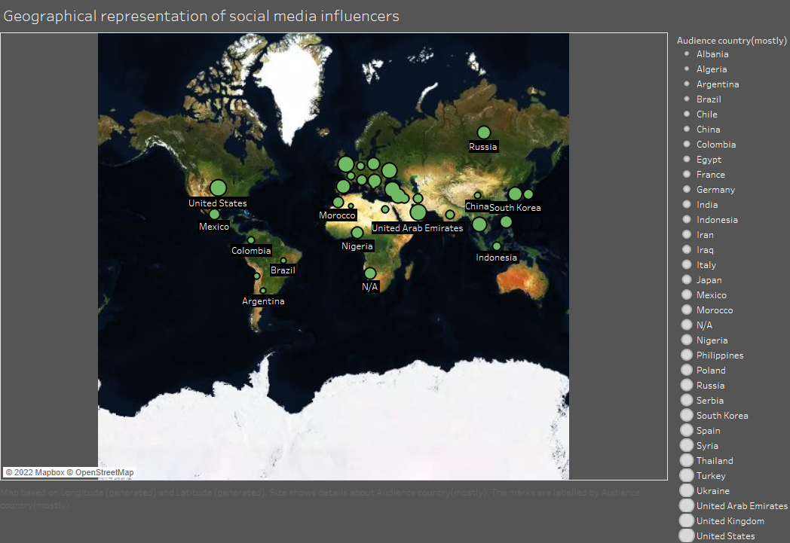

Figure 2: Geographical representation

Influencers’ audiences are mostly from North America, Europe and north Asia. Unfortunately can’t get any data on Australia. A recent survey by DataReportal, showed that India is now leading on the basis of instagram audience (Countries with most Instagram users 2022 | Statista, 2022). According to World Bank, the leading countries with highest GDP are USA, China, Japan, Germany, UK and India (Top 15 Countries by GDP in 2022 | Global PEO Services, 2022). These leading countries’ businesses now using social media marketing very successfully.

**Category of influencers**

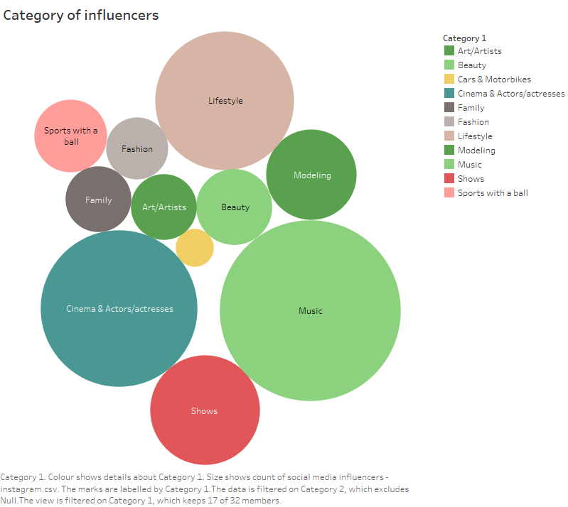

Figure 3: influencers’ category

This viz is showing Cinema & Actor/Actresses and Music industry related influencers are leading with their huge fan following. So business related to these fields will be more benefited and target those influencers for their marketing and sales of product. For example - If any company like CocaCola wants to advertise, they will target media influencers rather than lifestyle ones. Shortcoming is, category like Cars and Motorbikes aren’t viz here. This kind of viz is good to see the bigger categories but not good enough to show smaller ones.

**Top Influencers on Instagram**

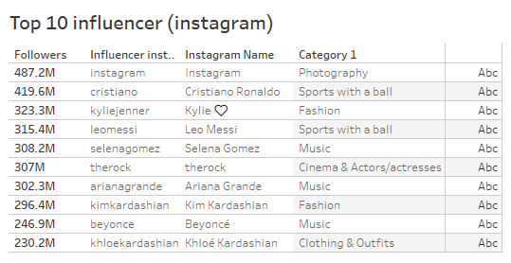

Figure 4: Top influencers by followers

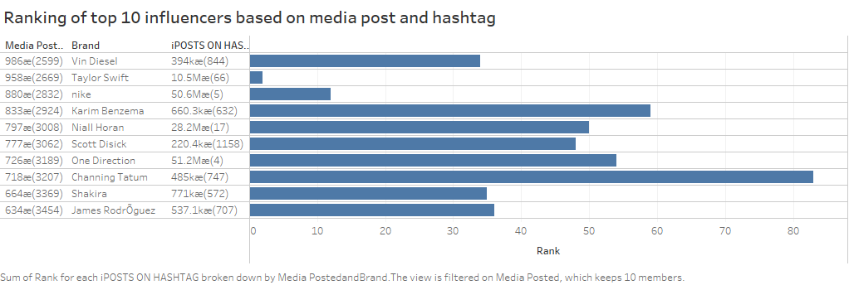

Figure 5: Top influencers by media post and hashtag

Though Cinema & Actor/Actresses and Music industry are the category with more influencers but in terms of followers Photography, Sports and Fashion are leading here too. When Cristiano Ronaldo removes two bottles of CocaCola, this cause a huge impact on shares of CocaCola worldwide (The Telegraph, 2021). According to USA Today CocaCola shares drop $5 billion after this event (Coca-Cola shares drop $5 billion after Cristiano Ronaldo's gesture to drink water, 2021). So not only companies profit or loss, human emotions are also involved. People love to influence by their loved influencers.

**Engagement rate (ER) of influencers**

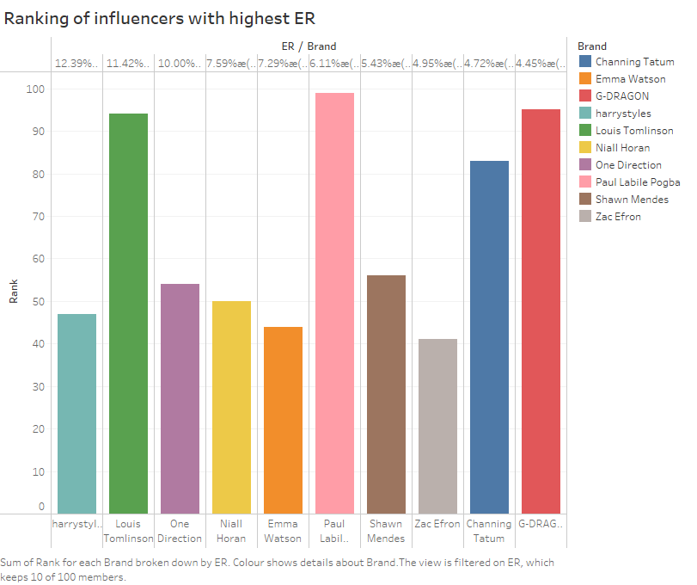

Figure 6: ER of top 10 influencers

Impacts of an influencer not only depend on how many followers they have, but also how people are engaged with them too. From the above viz, Harry Styles an English singer-songwriter has the most followers who consistently engage with him by like, comment, share etc. Ranking based on followers of him is also not bad. But from this viz we couldn’t say if all the highest rankers have more engaging followers or not. If we include all of them-

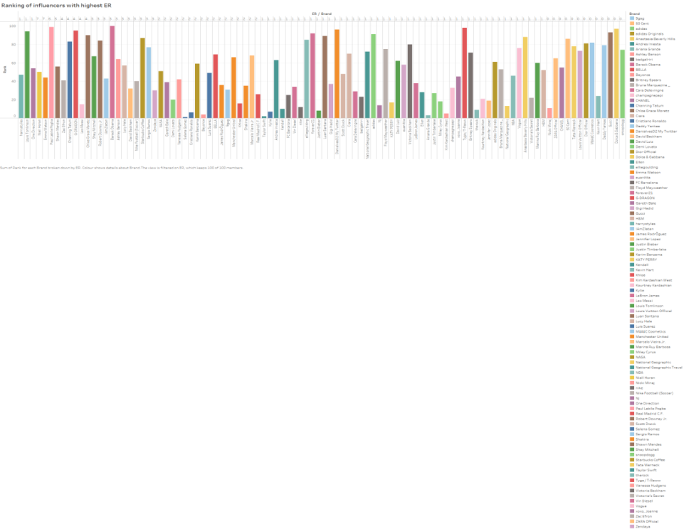

Figure 7: ER

Viz will be messy. So the first viz will be the recommend one.

**Peoples Thoughts**

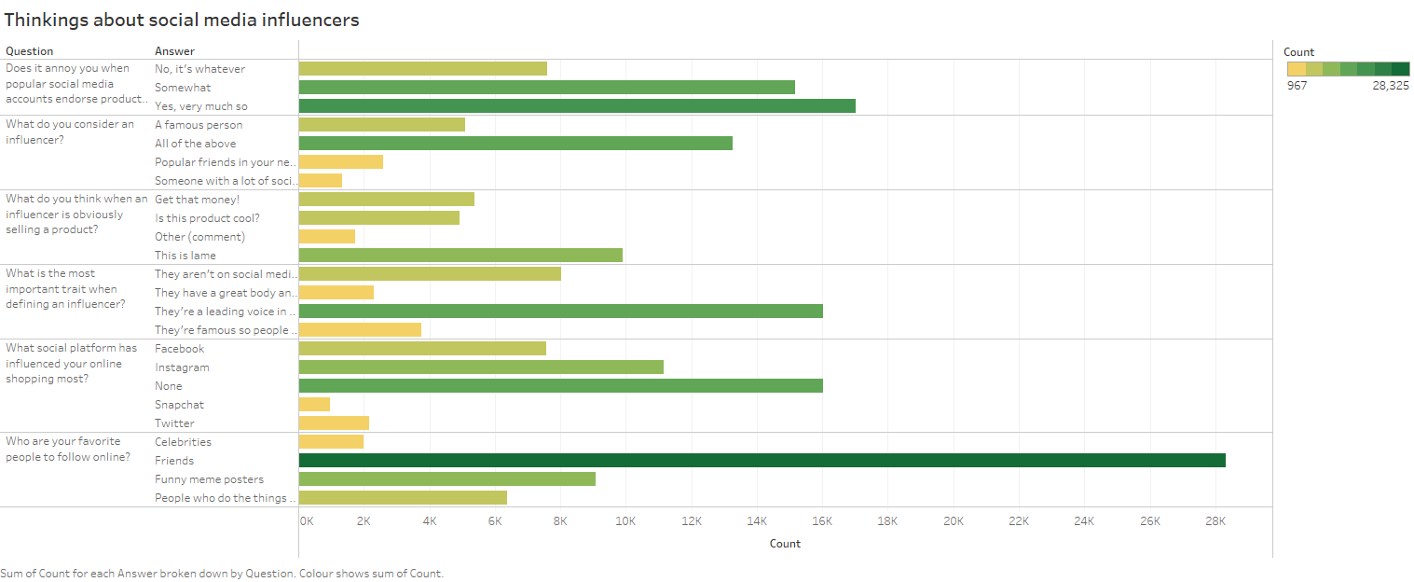

Figure 8: Q/A

People’s reactions to those questions are mixed. On the 5th question, people mostly agree that Instagram is the most influenced platform for online shopping. The viz is good enough to understand all variables.

**Conclusions and recommendations**

In conclusion, we could say that users are mostly following those who are already celebrities, the leading economy has more audience, cinema and music industry people are dominating social media, higher ranked influencers also got higher ER, although people are annoyed with online product endorsement they also influencing by that.

Possible recommendation will be

* Users should follow health and lifestyle influencers too. They will benefit by good health rather than wasting money.
* Influencers should target small economy too. Enlarging their area of influence, they could raise their endorsement value.
* Non-celeb influencers should give more effort to make more interesting content to attract more audience as they don’t have the advantage of being a celeb.
* Business should target micro and nano influencers, especially small or rising business. Micro and nano influencers don’t have brand value like celeb but they have the power to be a common people, their followers’ love them not like a celeb but like a friend who live next door.

**Appendices**

1. **Countries with instagram audience:**

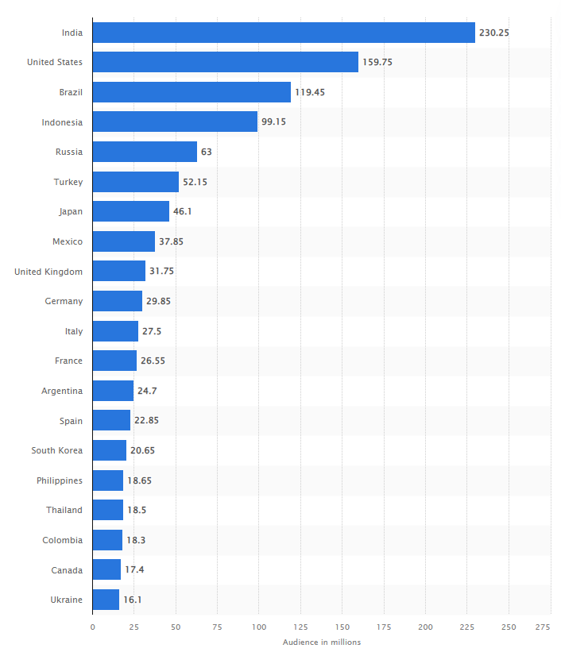

1. **Top countries with highest GDP:**
2. United States: $20.89 trillion
3. China: $14.72 trillion
4. Japan: $5.06 trillion
5. Germany: $3.85 trillion
6. United Kingdom: $2.67 trillion
7. India: $2.66 trillion
8. France: $2.63 trillion
9. Italy: $1.89 trillion
10. Canada: $1.64 trillion
11. South Korea: $1.63 trillion
12. Russia: $1.48 trillion
13. Brazil: $1.44 trillion
14. Australia: $1.32 trillion
15. Spain: $1.28 trillion
16. Indonesia: $1.05 trillion

**Bibliography**

* Halper, A., 2017. *data.world*. [online] Data.world. Available at: <https://data.world/ahalps/online-influencer-marketing/workspace/file?filename=Whatsgoodly+-+Thought+Catalog+Influencers.csv> [Accessed 28 September 2022].
* Kalegaonkar, C., 2022. *Most Followed on Instagram - dataset by socialmediadata*. [online] Data.world. Available at: <https://data.world/socialmediadata/most-followed-on-instagram> [Accessed 25 September 2022].
* SHARMA, U., 2022. *Influencers Analysis for Business Purpose*. [online] Kaggle.com. Available at: <https://www.kaggle.com/code/umasharma11/influencers-analysis-for-business-purpose/data?select=social+media+influencers+-+instagram.csv> [Accessed 25 September 2022].
* Statista. 2022. *Countries with most Instagram users 2022 | Statista*. [online] Available at: <https://www.statista.com/statistics/578364/countries-with-most-instagram-users/> [Accessed 25 September 2022].
* The Telegraph, 2021. *'Drink water': Ronaldo removes Coca-Cola bottles in press conference*. [video] Available at: <https://www.youtube.com/watch?v=x2ZLS1V3iMw> [Accessed 26 September 2022].
* Top 15 countries ccording to audience- Global PEO Services. 2022. *Top 15 Countries by GDP in 2022 | Global PEO Services*. [online] Available at: <https://globalpeoservices.com/top-15-countries-by-gdp-in-2022/> [Accessed 25 September 2022].
* Usatoday.com. 2021. *Coca-Cola shares drop $5 billion after Cristiano Ronaldo's gesture to drink water*. [online] Available at: <https://www.usatoday.com/story/money/2021/06/16/coca-cola-shares-dropper-after-christiano-ronaldo-moves-coke-bottles/5293590001/> [Accessed 26 September 2022].